

**COMSATS University Islamabad, Lahore Campus Department of Electrical and Computer Engineering**

# Assignment No 2-Spring 2025

|  |  |  |  |  |  |  |  |  |  |
| --- | --- | --- | --- | --- | --- | --- | --- | --- | --- |
| Course Title: | Data Comm & Computer Networks | | | | Course Code: | | CPE314 | Credit Hours: | 4(3,1) |
| Course | Engr. Ahmad Mudassir | | | | Program Name: | | BCE | | |
| Semester: | 6th | Batch: | FALL 22 | Section: | A,B | | Date: | 14-4-25 | |
| **Deadline** | **29th April 4 PM** | | | | **Maximum Marks:** | | | **20** | |
| Student’s name: |  | | | | Reg. No. | CUI/ /LHR | | | |
| **Important Instructions / Guidelines:**  Any copied answer script will be marked with zero grade.   * No Submissions after the End Time strictly. | | | | | | | | | |

**Question 1:**

Initially, assume that the client wants to retrieve the [www.cnn.com](http://www.cnn.com/) home page but has no information about the [www.cnn.com](http://www.cnn.com/) web server IP address.

[www.cnn.com](http://www.cnn.com/)

DNS root server



Internet

DNS .com server

local DNS server

Client Institutional Cache

**Figure 3**

1. Describe the process of the client obtaining the IP address for the hostname [www.cnn.com](http://www.cnn.com/) under the assumption that it is not cached at the local DNS server and that the local DNS server has not cached an entry for the .com DNS server. (Describe this for the recursive case!)
2. We know that [www.cnn.com](http://www.cnn.com/) is a very popular web site and the many client requests cannot be handled by a single server but rather by acluster of web servers (each having a different IP address). Describe the process that DNS offers for load balancing.
3. Give an example for the source and destination port numbers in aTCP segment sent from the client to the [www.cnn.com](http://www.cnn.com/) web server. Now assume a second browser is opened on the client which also wants to retrieve the [www.cnn.com](http://www.cnn.com/) start page. Identify the source and destination port for a TCP packet that belongs to this connection?
4. Let us turn our attention to the web server for this sub--‐problem. Assume that the main web page is a single HTML file (e.g., index.html) that isof size 350,000 bytes and the MSS is 1400 bytes. Further assume that the sequence number for the very first TCP segment carrying that data stream is 0. Identify the sequence number for the 2nd, 3rd, and 4th segment? Also give an expression for the nth TCP segment in that stream. Assuming there are no packet losses and timeouts, Identify TCP segments that are needed in total to transmit that HTML page?
5. Now assume there’s an institutional cache in the client’s subnet. The client’s initial request is cached by this cache. Since news pages changefrequently the client wants to make sure that it does not get served an outdated HTML page from the cache. Explain the HTTP mechanism that prevents this from happening. Identify the body of the second server reply if the reply would be 304 Not Modified?
6. Consider the sliding window protocol in Figure 4. Identify wheather this figure indicate the Go--‐Back--‐N, Selective Repeat, or there is not enough information to tell?

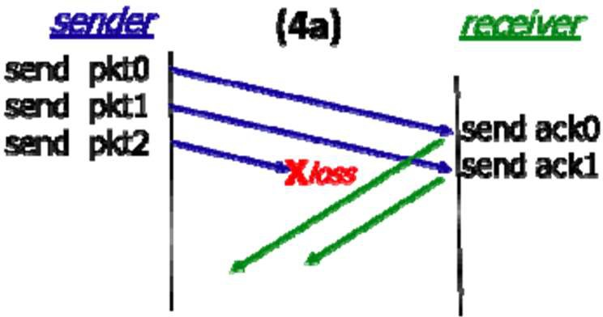

**Figure 4**

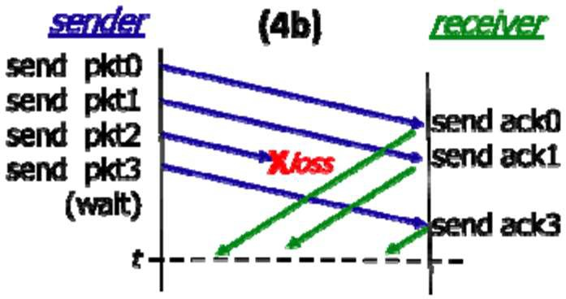

**Figure 5**

1. Consider the sliding window protocol in Figure 5. Identify that wheather the figure indicate the Go--‐Back--‐N, Selective Repeat, or there is not enough information to tell? Explain your answer briefly.
2. Consider Figure 5 again. Suppose the sender and receiver windows are of size N = 5 and suppose the sequence number space goes from 0 to 15. Show the position of the sender and receiver windows over this sequence number space at time t (the horizontal dashed line).

Page **2** of **3**

1. Suppose that it take 1 ms to send a packet, with a 10 ms one--‐way propagation delay between the sender and receiver. The sliding windows size is again N = 4. Identify the channel/link utilization?
2. Assume a TCP sender transmits 4 TCP segments with respective sequence numbers 1200, 2400, 3600, 4800, 6000. The sender receives four acknowledgements with the following

sequence numbers, 2400, 2400, 2400,2400, 7200. Complete Figure 6 to show what TCP segments are exchanged between sender and receiver.



Seq #:1200

Seq #:2400

**Figure 6**

# The End Good Luck ●•놶놷놳

Page **3** of **3**